 | Learner  News Alert  December 2025


Welcome to our December Newsletter!
Dear Learners,

As the year draws to a close, we’d like to take a moment to celebrate you – our dedicated learners! This season, we’re here to reflect on your hard work, growth, and achievements over the past year. Whether you’re just starting your journey or already well on your way, your commitment and drive in balancing work, learning, and personal goals is inspiring.
Thank you for being a part of our learning community. As you continue to build your skills and grow in your roles, remember that we’re here to support you every step of the way. Let’s finish this year strong and look forward to a bright 2026!

Warm wishes,
Sue Tipton (MD)
Protocol Consultancy Services
high-quality training, and encouragement to ensure you reach your full potential.

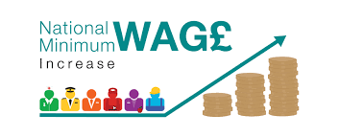
Employee Wage Rise

National Minimum Wage April 2026
Apprentice minimum wage to rise to £8 (45p rise, or 6 per cent, from the current £7.55 per hour)
Employers must pay at least the apprentice minimum wage for apprentices aged 16 to 18, and for apprentices aged 19 or over in the first year of their apprenticeship.
After their first year, apprentices aged over 19 should receive at least the national minimum wage, or the national living wage, depending on their age.
The national minimum wage for 18 to 20-year-olds will rise by 8.5 per cent to £10.85 per hour. And the national living wage will also rise by 4.1 per cent from £12.21 to £12.71 per hour for workers aged 21 and over.
New hourly rate will apply from April 2026


We’d love your feedback
If you’ve enjoyed your experience with Protocol Consultancy Services, we’d really appreciate it if you could take a moment to leave us a Google review.
Your feedback helps us improve our support and also helps future learners decide to join us. It only takes a minute, and your comments genuinely make a difference.
Leave a review here:
https://www.google.com/search?q=protocol+consultancy+services#lrd=0x4870bc8d3d8647f5:0x321f4d0634d1cff5,1 (click the link then click on Write a review)
Thank you for being part of Protocol and for sharing your experience.



Protocol Consultancy Services award recognition
Protocol is one of 57 recipients who have achieved the Princess Royal Training Awards standard in 2025!
Protocol have been awarded for our excellent CPD and Internal mentoring program that drives external impact.


Sue Tipton (MBE and Managing Director) and Craig Higham (Operations Director) pictured attending the awards ceremony in London on Tuesday, 2 December 2025.
https://princessroyaltrainingawards.com/2025-recipients/

The Princess Royal Training Awards (PRTAs) are a national honour that recognises employers in the UK who demonstrate outstanding commitment to training, employee development, and workplace learning. They are run by the City & Guilds Foundation and personally approved by HRH The Princess Royal.
By winning it, Protocol has demonstrated high quality training, leadership in skills workforce development and organisational culture, making it a highly valuable accolade for reputation, recruitment, and long-term business credibility.


Refer a Friend
At Protocol Consultancy Services, we’re excited to remind you of our Refer a Friend scheme, giving both pre-apprenticeship learners and apprentices the opportunity to share the benefits of our pre-apprenticeship programme with others. If you refer a friend who joins our programme, and they successfully complete their course you’ll receive a £50 voucher as a thank you for helping us grow our learning community. It’s a win-win: your friend gets the chance to develop valuable skills, while you’re rewarded for playing a key role in their journey. We’re thrilled to offer this initiative, and we look forward to welcoming more learners through your referrals!


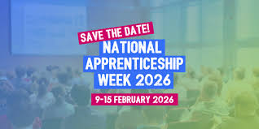
NAW 2026 9-15 February 2026
National Apprenticeship Week brings together the entire apprenticeship community to celebrate everything that is amazing about apprenticeships.

Protocol will be hosting an open event during that week. We will be in contact with employers to support the event by attending and presenting an employment/career overview to our learners or apprenticeship applicants. More information on date and times to follow.

EPA (End Point Assessment) Success


All staff at Protocol would like to congratulate all learners that achieved their EPA in 2025, the majority of whom have achieved Distinctions.

Protocol Off-The-Job CPD
Please remember to regularly update your CPD on Mahara ensuring the hours recorded meet the required OTJT hours as set out in your Individual Training Plan, and you are recording your Key Learning.

Learning Development Progression through Protocol

Did you know that you can complete more than 1 apprenticeship? If you are currently undertaking your first apprenticeship, preparing for EPA, or recently passed your EPA; Protocol can support you with further personal development through a second apprenticeship.
This could be to support an increase in responsibility, leading or managing a team, or a change to job role/promotion with new tasks and responsibilities.

Progression pathway examples include:
Customer Service Level 2 > Customer Service Level 3
Business Administration Level 3 > HR Support Level 3 or Team Leader Level 3
HR Support Level 3 > People Professional Level 5
Team Leader Level 3 > Operations Manager Level 5 > Senior Leader Level 7
Digital Marketing/Multi Channel Marketing > Marketing executive Level 4
Plus, more!!!

Please speak with your training adviser, employer or contact us for more information.

TOTUM PRO student discount card (Available for all Apprentices)
Buy your TOTUM PRO apprentice card online.
TOTUM Student+, Professionals and Apprentice members can enjoy the benefits of tastecard and Coffee Club membership for FREE - on top of the 350+ discounts you already get! LIVE YOUR BEST LIFE, FOR LESS with TOTUM!
https://www.protocolgroup.org.uk/learner-area/
https://totum.com/
TOTUM Apprentice is available to all people undertaking an apprenticeship.


Travel schemes for Apprentices across the West Midlands

https://nxbus.co.uk/west-midlands/offers/workwise

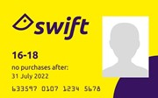

https://www.tfwm.org.uk/swift-and-tickets/discounts-and-free-travel-passes/swift-16-18-photocard/

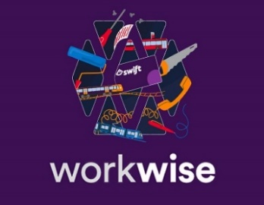
https://workwise.networkwestmidlands.com/Home/Step0

1st for Awarding Apprentice Wellbeing Hub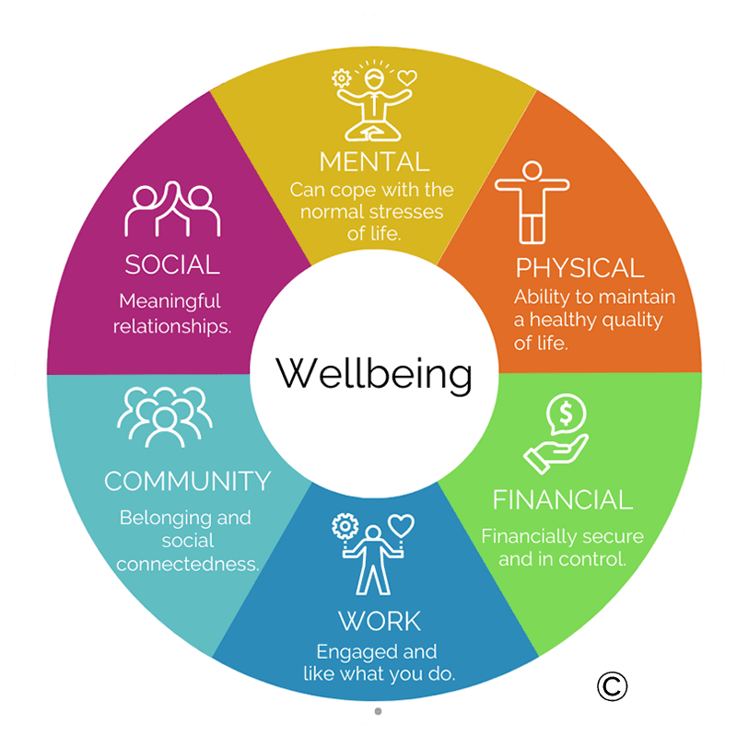

Good mental health and wellbeing is paramount. For us at Protocol Consultancy Services, it has enormous benefits in terms of keeping our apprentices focused, engaged, and staying on programme to complete their apprenticeship.
As an apprentice, you have a lot to balance. Work, training, EPA preparation – as well as your personal life. 1st for Awarding Apprentice Wellbeing Hub has resources to support you through it all. Take control of your wellbeing and you’ll be in the best position to complete your apprenticeship and end point assessment (EPA).
If you feel unable to cope, please speak to one of Protocol’s personal development coaches, and/or click on to link for further support here.

For further information on any of the above please speak with your tutor or training adviser or call 0121 236 2634.







