 | Employer  News Alert  December 2025



Welcome to our December Newsletter!
Dear Employers,

As we approach the end of another successful year, we want to extend our gratitude to each of you for your ongoing support and partnership. Your commitment to providing opportunities, mentorship, and guidance to learners is what enables growth and success.
In this edition, we’ll be highlighting some of the achievements from the past year, sharing insights on workforce trends, and providing updates on upcoming training initiatives that can benefit your teams in 2026 including supporting with work placements. You will also find resources designed to support both new and current apprentices as they navigate their career journeys with your guidance. Thank you for the vital role you play in shaping future talent. We’re looking forward to continuing to work together to equip learners with the skills and experience they need to thrive in the workforce.

Warm regards,
Sue Tipton (MD)
Protocol Consultancy Services


Press Release
Autumn Budget 2025 - Further Education Budget Impact

National Minimum Wage April 2026
Apprentice minimum wage to rise to £8 (45p rise, or 6 per cent, from the current £7.55 per hour)
Employers must pay at least the apprentice minimum wage for apprentices aged 16 to 18, and for apprentices aged 19 or over in the first year of their apprenticeship.
After their first year, apprentices aged over 19 should receive at least the national minimum wage, or the national living wage, depending on their age.
The national minimum wage for 18 to 20-year-olds will rise by 8.5 per cent to £10.85 per hour. And the national living wage will also rise by 4.1 per cent from £12.21 to £12.71 per hour for workers aged 21 and over.
New hourly rate will apply from April 2026

Apprenticeships:
The government is set to scrap co-investment payments that small and medium-sized employers have to pay for apprentices under the age of 25 - meaning training will be fully funded — from the 2025/26 financial year.
Use of Levy funds for short courses to be introduced from April 2026.
The existing Apprenticeship Levy (or its successor “Growth and Skills Levy”) will be made more flexible: from April 2026, employers will be able to spend some levy funds on short, modular courses (often referred to as “short courses” or “apprenticeship units”), as well as on full-length apprenticeships.
The first round of these short-course offerings will focus on sectors and skills considered critical by government, such as digital, engineering, advanced manufacturing areas listed in the government’s industrial strategy.
It is unclear what proportion of levy funds will be allowed for short-course funding vs full apprenticeships (i.e. whether there will be caps, or if full apprenticeship funding will remain priority)



Protocol Consultancy Services award recognition
Protocol is one of 57 recipients who have achieved the Princess Royal Training Awards standard in 2025!
Protocol have been awarded for our excellent CPD and Internal mentoring program that drives external impact.



Sue Tipton (MBE and Managing Director) and Craig Higham (Operations Director) pictured attending the awards ceremony in London on Tuesday, 2 December 2025.
https://princessroyaltrainingawards.com/2025-recipients/

The Princess Royal Training Awards (PRTAs) are a national honour that recognises employers in the UK who demonstrate outstanding commitment to training, employee development, and workplace learning. They are run by the City & Guilds Foundation and personally approved by HRH The Princess Royal.
By winning it Protocol has demonstrated high quality training, leadership in skills, workforce development, and organisational culture, making it a highly valuable accolade for reputation, recruitment, and long-term business credibility.


NAW 2026 9-15 February 2026
National Apprenticeship Week brings together the entire apprenticeship community to celebrate everything that is amazing about apprenticeships.

Protocol will be hosting an open event during that week. We will be in contact with employers to see if you would like to support the event by attending and presenting your company overview to our learners or apprenticeship applicants. More information on date and times to follow.

Work experience/placement pledges Work experience/placement pledges
This year we had 20 employer pledges from local employers that we have worked with supporting our learners on their pre-apprenticeship programme through offering a quality and valuable work placement for up to 10 weeks. Thank you for your support.
In 2026 Protocol is looking for 30 employer pledges to offer valuable work experience through a work placement to our learners on their Pre-apprenticeship programme.
Youth unemployment in parts of the West Midlands, particularly in areas like Birmingham, Wolverhampton and Walsall, is more than double the national average, creating a cycle of economic stagnation that affects us all. When young people struggle to find work, it not only hinders their personal and professional development but also deprives businesses of fresh talent and innovative ideas that are vital for growth.
By pledging to offer work placements, we can help provide the vital experience young people need to build their careers while simultaneously fostering a pipeline of skilled, motivated talent for local businesses. We’re committed to supporting this initiative and making the West Midlands a hub for local talent, a region that not only nurtures its young people but is also an attractive and competitive place for businesses to invest and grow.
Your pledge will make a real difference in turning the tide on youth unemployment and ensuring that the next generation can succeed.
We have learners that can commute to your location, with interests ranging from Business Administration, HR, Customer Service, Sales, IT, and Digital Marketing.
If you can support, we are looking for employers who can offer a placement for four days per week (Monday to Thursday), for between 4 – 10 weeks.
At Protocol, we support 16–18-year-olds on our programme designed to help young people gain real workplace experience and prepare for future employment or apprenticeships.
About the Programme
- Learners complete up to 10 weeks of unpaid work experience with an employer.
- They attend Protocol one day per week usually a Friday and spend up to four days per week with the employer (max 6 hours per day).
- Employers can interview and select their learner or allow us to identify a suitable match.
- Learners receive a travel bursary from Protocol if eligible. Employers are not required to pay wages but may provide lunch or small incentives if they wish.
- At the end of the placement, employers are asked to provide either a job interview, apprenticeship opportunity, or employer reference.
Future Cohorts
- Next cohort: Monday, 02nd February 2026, with further groups starting every two months (10–12 learners each intake).

This ongoing cycle means there will be regular opportunities to host a learner should you wish to continue supporting the programme.
By providing a placement, you will not only be helping a young person gain valuable experience but also can assess potential future recruits before offering employment or an apprenticeship.
Get in Touch for More Information or to Make an Inquiry
Contact Us: 📞 Phone: 0121 236 2634 Adrian Hunt – Business Development Manager
📧 Email: ahunt@protocolgroup.co.uk


End Point Assessment - Employer Role
As part of the apprenticeship journey, the End Point Assessment (EPA) plays a crucial role in evaluating the knowledge, skills, and behaviours (KSBs) that learners have developed throughout their programme.

At Protocol Consultancy Services, we conduct mock EPA interviews that cover various elements linked to these KSBs, helping learners prepare for the real apprenticeship assessment.
However, we believe your involvement would add significant value to this process. By inviting learners to present their project or presentation to you and engaging them with IQA (Internal Quality Assurance) questions, you provide them with a realistic experience that not only boosts their confidence but also gives them invaluable feedback. Your input helps ensure they are fully prepared and capable of demonstrating their competencies in a professional setting, enhancing their readiness for their final EPA. We would greatly appreciate your support in making this final step in their apprenticeship journey a success.

EPA (End Point Assessment) Success

All staff at Protocol would like to congratulate all learners that achieved their EPA in 2025, the majority of whom have achieved Distinctions. We would also like to thank our employers and mentors who played a big part in supporting their employees to achieve apprenticeship EPA success.

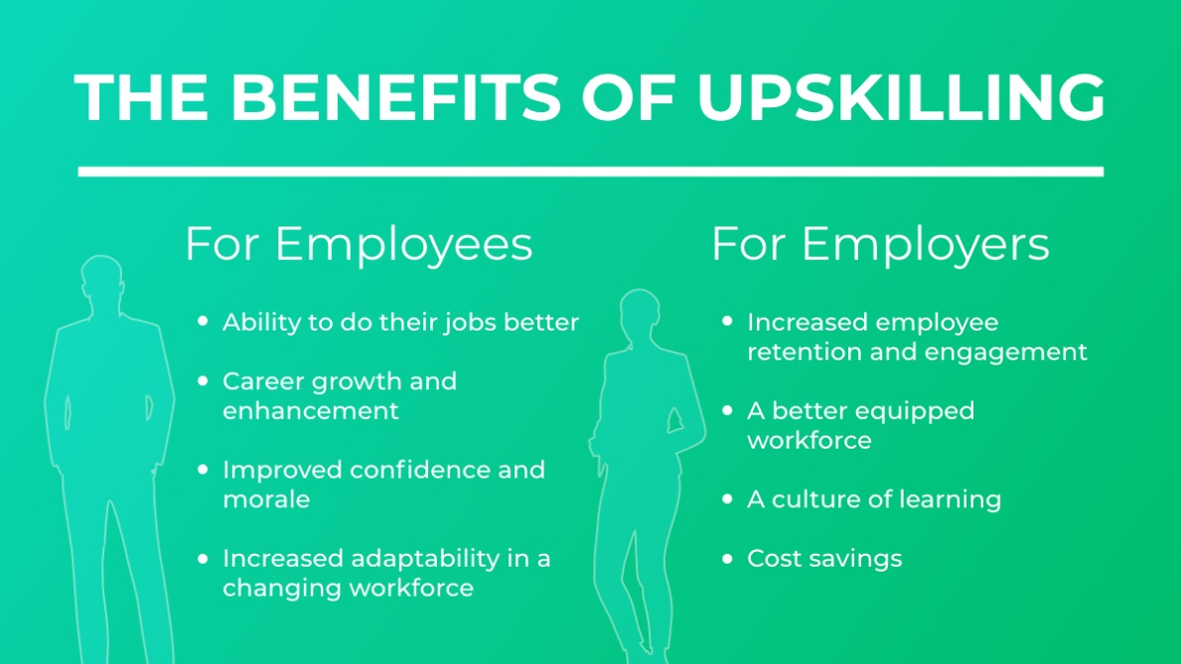

At Protocol Consultancy Services, we offer a range of commercial training options tailored to meet the specific needs of your business and employees. Whether it's short courses or workshops on essential skills like Excel, Leading a Team, Time Management and more, we are happy to deliver these training sessions for a small cost. These sessions can be a valuable investment in your team's development, enhancing their productivity and effectiveness in the workplace. If you have any training requirements or would like to discuss how we can support your employees' growth, please get in touch. We’re here to help build the skills that drive your business forward.

Apprenticeships for existing employees
Why would an existing member of staff want to do an apprenticeship?
The perception of apprenticeships is changing. Traditional preconceptions that apprentices can only be entry-level school leavers or labour-intensive workers are evolving. With the employer-led redesign of apprenticeship standards, apprenticeships are more highly valued training and education routes, which emphasise quality, knowledge, and practical skills.
- Did you know that a Level 5 apprenticeship is equivalent to a foundation degree, or a Higher National Diploma
- Did you know that there may be up to 100% government funding available and/or that you can use your Apprenticeship Levy to upskill your employees

An example of upskilling an employee would be through the Operations or Departmental Manager Level 5 Apprenticeship and/or **Senior Leader Level 7 Apprenticeship**!
(**ACT NOW - FUNDING DUE TO END 31st DECEMBER 2025 for Level 7**)

Typical job titles: Operations manager, Regional manager, Divisional manager, Department manager and Specialist managers.

Do you have employees in the above roles, or are you looking to progress employees through succession planning into these roles? If ‘YES’, then Protocol can support through the delivery of the Apprenticeship through our flexible learning model.

Requirements: Knowledge, Skills and Behaviours
- Organisational performance – delivering results
- Interpersonal excellence – managing people and developing relationships
- Personal effectiveness – managing self
- Organisational performance – delivering results
- Interpersonal excellence – managing people and developing relationships
- Personal effectiveness – managing self
- Behaviours – What is required (developed and exhibited in the workplace)
You will find all the Apprenticeship Standards that Protocol delivers on our website:
https://www.protocolgroup.org.uk/apprenticeships/

Mentor’s update workshops
 | Protocol would like to thank the mentors that attended our recent Mentor Workshop and wish you a successful journey working with and supporting your apprentice(s).  If you are an existing mentor yet to attend one of our Mentor Workshops via MS Teams and would like to attend the next one, please respond to this email or contact your learner’s Training Advisor to let us know. Protocol will send an invite to all mentors.  Next mentor workshop via TEAMS  Will take place in February 2026

Learning Development Progression through Protocol
Did you know that your employees can complete more than 1 apprenticeship? If you have an employee currently undertaking their first apprenticeship, preparing for EPA, or recently passed their EPA Protocol can support them with further personal development through a second apprenticeship.
This could be to support an increase in responsibility, leading or managing a team, or a change to job role/promotion with new tasks and responsibilities.

Progression pathway examples include:
Customer Service Level 2 > Customer Service Level 3
Business Administration Level 3 > HR Support Level 3 or Team Leader Level 3
HR Support Level 3 > People Professional Level 5
Team Leader Level 3 > Operations Manager Level 5 > Senior Leader Level 7
Digital Marketing/Multi Channel Marketing > Digital Support technician L3 > Marketing Executive Level 4

For further information on any of the above please contact a member of the Protocol team on 0121 236 2634.
For recruitment and business development contact Adrian Hunt ahunt@protocolgroup.co.uk
Transworld Publications Services Ltd t/a Protocol Consultancy Services






